(Report title)
(Apprenticeship Final Report)
(1/7/2025~ 29/2/2026)

Student Name:Mohammad Hani Al-shenaiwer
Student ID Number:22110066
Department: Penetration Testing and Vulnerability Assessment Management
Academic Mentor: Shareef Shargawi

Table of Contents
General Introduction: 1
Detailed Description of the program 2
SECTION 1: Company Work 3
SECTION 2 : Projects 4
SECTION 3 5
Conclusion 6
Appendices 7

- General Introduction:
During my apprenticeship at Arab Bank, I was part of the Penetration Testing and Vulnerabilities Assessment (PTVA) management team. I gained hands on experience in the security testing process, compliance monitoring and vulnerability management, I started by understanding the internal organization structure and how does each application start and its life cycle in the Bank to the point it reaches the customer and then understanding the internals tools used for endpoint security compliance and progressed towards supporting penetration testing for both internal systems (in testing environment ‘adhooc’) and the live production testing, during these times I increased my knowledge in tools like FireEye, WSUS, SCOM, Tenable.SC, rapid 7 and Neu-Vector, while participating in test coordination and reporting.
Arab Bank is one of the leading financial institutions in the Middle East, known for its commitment to secure digital banking services. Throughout my apprenticeship, I was introduced to the security assurance processes used to protect the organization’s IT services.


Throughout my apprenticeship, I worked in two departments: Security Assurance where I started my apprenticeship for a little time roughly two months. After that I worked as Penetration Testing and Vulnerability Assessment (PTVA) management team for the rest of the apprenticeship duration and supported teams with security assessments and vulnerability management processes.

- Detailed Description of the program
Throughout the 8 months apprenticeship, I gained hands-on experience and participated in tasks regarding penetration testing management, compliance monitoring and vulnerability assessment the duration was divided into many stages as shown below:
- Stage 1: Initial training on FastAPI, docker and Kubernetes.
- Stage 2: Supporting the PTVA team with internal testing coordination with the developers to test new features before deploying them to the production environment (in between the customer hands).
- Stage 3: Managing live production test cases, coordinating between external testers and internal teams to ensure the testing of the live application without affecting the service.
- Stage 4: Gaining understanding of vulnerability assessment tools like Tenable.SC, rapid 7 and NeuVector monitoring vulnerabilities, and prioritizing patch management.

List of criteria (National Occupational Standards):
- TECIS60442 – Plan penetration tests
- TECIS600201 – Identify cyber security threats and vulnerabilities
- SEMP_MO221 – Contributing to Effective Team Working
- TECDT61131 – Assist in Implementing Vulnerability Assessment Processes
- TECHDUCO1 – Perform coding for simple business problems
- SECTION 1: Company work

During the apprenticeship working as a penetration testing and vulnerability assessment management team my main tasks was the following:
- Supporting internal and external testing exercises
- Participating in coordination meetings with both internal developers and external penetration testing vendors
- Managing compliance reporting for endpoints and server security
- Analyzing CMON compliance data and filtering the result for report accuracy to the hire ups in the Bank
- Assisting with vulnerability scans and reporting using Tenable.SC (observational phase)

Detailed explanation regarding internal and external penetration testing (TECIS600201)
At the start for both internal and external PT we start by scheduling a meeting with the corresponding team that is responsible for explaining the scope of the application what we will be testing and the flow of the application for the external it will be the whole application (some features will be consider out of scope due to some issue with the data or the features directly link to third parties) ,by that we did the Nos (TECIS60442 – Plan penetration tests) after the meeting we provide the vendor all the requested test data so they can start the PT exercise and if they have some issue like connection issue or builds issue we follow up with either developer team for the builds or technical issue or with the network team for the connection issues or with the quality control team for the test data if no issue occur and we receive the report form the vendor we check the finding and report them with the developer to fix it the report show all the vulnerabilities and their likelihood and impact with the proof of concept
(steps how to trigger the vulnerability) by that the Nos(TECIS600201 – Identify cyber security threats and vulnerabilities and)
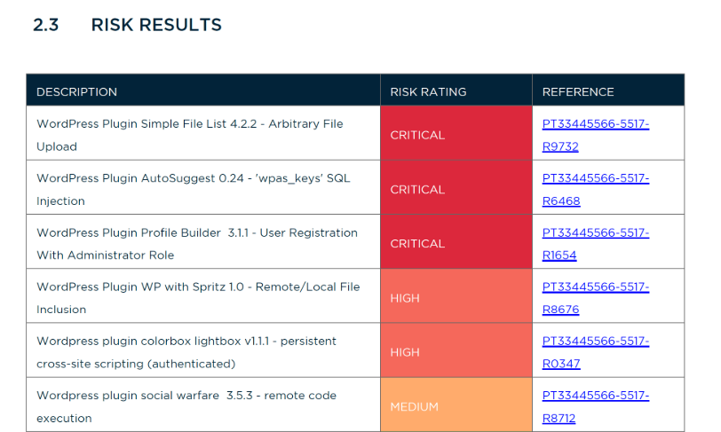
After the developer inform us that all the finding are clean then we inform the vendor to retest the cases to see if they are indeed clean once they are clean we give the clearance for it this for the internal testing for the external if have similar flow but the finding take more time get fix firstly in a test environment then be deployed in the production where we found the vulnerability

Detailed explanation regarding Managing compliance reporting CMON
During my apprenticeship I was responsible for analyzing CMON compliance data. The compliance monitoring tool provided key information regarding security controls implemented across endpoints, servers, and network devices. My main role was to filter and summarize compliance reports based on endpoint security statuses from various tools like DLP, FireEye, WSUS, and SCOM by that ensure implementing security controls and doing Nos (TECDT61131 – Assist in Implementing Vulnerability Assessment Processes).
I used Excel to visualize the results, track non-compliant devices, and create summary reports that were shared with senior management. Compliance metrics were reviewed regularly to ensure that systems met the required security standards.
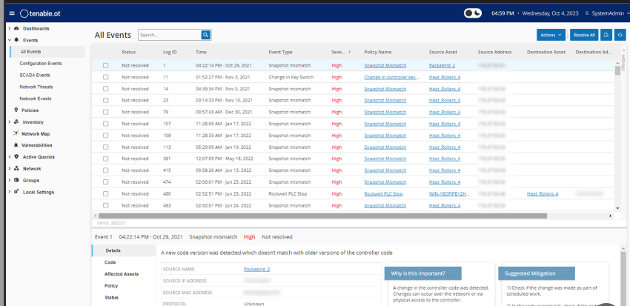

At the start of the training my old manager (Sari) had me writing different simple codes that is related to the company services so I can be familiar with the flow and the structure of the work by that doing this Nos (TECHDUCO1 – Perform coding for simple business problems)

Challenges faced and how I overcame them:
• Coordinating between multiple teams for live system tests – kept a list for everyone a communicated with and what the reason to know exactly every team what they can help me with

Self-Reflection:
I improved my ability to communicate between teams and handle time-sensitive tasks. I gained a deeper understanding of vulnerability scanning, risk assessment, and the importance of accurate reporting in real-world environments.
Technical skills: Endpoint security compliance, vulnerability assessment, report analysis.
non-technical skills: Communication, time management, reporting.

- SECTION 2: Projects

I worked on:
• Penetration testing management for internal applications.
• Coordinating testing schedules with app owners and external vendors.
• Monitoring and reporting endpoint compliance using CMON.
• Reviewing vulnerability scan reports and interpreting findings for further action.

One of the projects I worked on was a added feature to one of the Arab bank applications the flow of the project was as following
- Arrange a time for a meeting for the vendors (pen testers) with the developers who created the feature and the security infrastructure team to determine the scope.
- In the meeting the developer explained the feature logically and as business wise and the security infrastructure decided the scope of the exercise after that we decided on a timeline for the project.
- Then the vendor sends all the requirements needed to conduct the pen test and I start working on them trying to coordinate with different teams to provide the requirements.
- The pen tester then starts the PT exercise if he faces any kind of issue, I try solving them from my end if I cannot then I arrange a call with the developer to solve the issue.
- If the exercise is finished without any issues, we receive a report from the pen tester containing all the vulnerabilities found then I start coordinating with the owner to fix of them once they from that they are fixed I provided the new builds and data to the tester to retest the feature just to be sure that the feature is secure
- after that we provided clearance from the my side that the feature is clean and ready to be deployed

- SECTION 3:
- Conclusion
Overall evaluation for the apprenticeship journey and its impact on the apprenticeship personal and academic level
Overall, my apprenticeship experience at Arab Bank provided me with the opportunity to learn and apply cybersecurity principles in a real-world setting. Working alongside security professionals, I was able to contribute to the vulnerability management processes and gain practical experience in penetration testing, risk analysis, and compliance reporting. This experience has enhanced my understanding of cybersecurity and has provided me with essential skills to continue my career in the field and increase my overall knowledge in the cybersecurity filed since before the apprenticeship I did not exactly the roles and jobs that the major can provide and what the daily tasks for the any employe in this major will be but due to the apprenticeship I gain that knowledge.

